Stable isotope approach to farming and husbandry practices at Phoenician site of Castro Marim between 8th – 5th century B.C.E

2021-09-02

Castro Marim is an Iron Age site from the Algarve region, Portugal. The earliest evidence of settlement dates to the 9th-century B.C.E, with the Phoenician-Punic period ending with the 3rd century B.C.E. The study focuses on stable isotope analysis of plant and faunal remains to reconstruct the cultivation and husbandry practices. Barley was the most abundantly cultivated cereal crop. The stable isotope results of barley indicate that it depended primarily on natural precipitation with a certain intensity of manuring. The extracted differences from stable isotope data of various fauna indicate a diverse management strategy for different species based on their economic importance and maximize the output of animal by-products.

# 1 Introduction

Iberian Peninsula underwent Oriental colonization by thalassocracy influences originating from the Near East in the Early Iron Age (8th – early 5th centuries B.C.E). These colonizers, referred to as Phoenicians, were mostly culturally homogeneous and politically independent city-states with the Levant’s power nucleus (present-day Lebanon) (Dietler, 2009; Gomes and Arruda, 2018; Quinn, 2019). The city-states served as nodes of an expansive trade network across the Mediterranean, including the Atlantic coast of Europe (Aubet, 2001; Markoe, 2005). It is widely accepted that the main driving force behind this westward expansion was the need to establish a stable supply of metalliferous resources (Arruda, 2009; Aubet, 2001; Eshel et al., 2019; Markoe, 2005). Phoenicians have mined the Iberian Pyrite belt for silver, tin, lead, and copper circa early 800 B.C.E (Eshel et al., 2019; Renzi et al., 2012; Wood et al., 2019). These mined metals were hauled back to the inner Mediterranean region through their well-established networks through posts along the rivers and southern shore of the Iberian Peninsula (Eshel et al., 2019).

The intense and prolonged density of settlements along the Southern Iberian coast cannot simply be explained by the quest for mineral sources, primarily because most of them are situated in locations with neither metallogenic minerals nor indigenous settlements. This settlement pattern is further emphasized by the contrast between the densely clustered settlements of Iberia and sparsely scattered settlements of North Africa. Other factors influencing the settlement density include agricultural resources (Wagner and Alvar, 2003; Wagner and Alvar, 1989), exploitation of marine resources (salt (Manfredi, 1992), and Tyrrhenian Purple production (Uriel, 2000)), timber (Treumann, 2009; Treumann, 1998), and labor force (Arrastio, 2000, 1999). The Phoenician traders had to ensure stable sources of food for the population apart from the industrial activities. Southwestern Iberia has been noted for its rich mineral veins and abundant natural fertility, and the Phoenicians exploited this fertile landscape while actively transforming it – including cultivable land (Arruda, 2009, 2003; Neville, 1998; Roller, 2014). The Phoenicians’ metal exploitation perspective has been studied, but the agricultural aspects have received little attention. This study aims to shed light on the stable isotope approach to reconstruct the farming strategies and animal husbandry practices in the Phoenician – Punic period of Portugal, specifically at Castro Marim.

# 2 Context

## 2.1 Phoenician - Punic Agriculture

Most knowledge about Phoenician and Punic agriculture comes from the famous treaty by Mago, of which only a few fragments have survived and subsequently translated (Martin, 1971). Other accounts are by authors from the Greek and Roman domains, usually written centuries after the demise of the Phoenician – Punic civilization. The current understanding has been mainly developed due to systematic excavations of different Phoenician – Punic settlements in Iberia and subsequent zooarchaeological and archaeobotanical studies on the recovered faunal and botanical remains (Aubet, 2001; Wagner and Alvar, 2003; Wagner and Alvar, 1989). The Southwest Iberian region has been praised by Strabo (3, 2, 8) for possessing the rare combination of abundant mineral deposits and natural fertility (Roller, 2014). From the 9th century B.C.E, Phoenician presence is noted in the Iberian Peninsula along the Atlantic’s coastal zone. This strategic location gave them reasonable access to the sailing routes and provided them with a plethora of cultivable land (Aubet, 2001). Colonies in Iberia were located in a landscape similar to that in the Levant with proximity to the coast and marked with steep mountain ranges and riverine valleys. Being located in a river valley gave the colonizers the ease of adapting existing practices from the Mediterranean in the Iberian hinterland. This included modifying and adapting the landscape to suit their agricultural needs, comprising farming and animal husbandry (Gómez Bellard, 2019).

Agricultural techniques from the East, such as irrigation, were used to improve upon the native practices. The iron production technology gave more robust implements such as plowshare etc., to the farmers. Better yielding cultivars (Eg: grapes and olives) and new species of animals (Eg: horse, donkey, and chicken) were introduced (Davis, 2007; Queiroz et al., 2006). Following the “sixth century crisis”, the colonies in Iberia came under Carthage’s influence, and this period is referred to as the Punic period (Arruda et al., 2013). The crisis had multiple facets, of which one of the leading causes was the exhaustion of Iberia’s mineral resources. This crisis forced the settlements to change their economy from an industry-driven one to a more agronomic-based one. This economic change brought a drastic change in space use concerning both settlement and domain. In the Punic period, in addition to the cultivation of cash crops and wine, local usable arboreal products were identified and exploited to boost exports (Gómez Bellard, 2019; Neville, 1998). The exploitation of arboreal products and perennial crops meant the existence of both short-term and long-term agricultural investments. Such diverse investments with different harvest times must have led to the development of a complex agricultural economy.

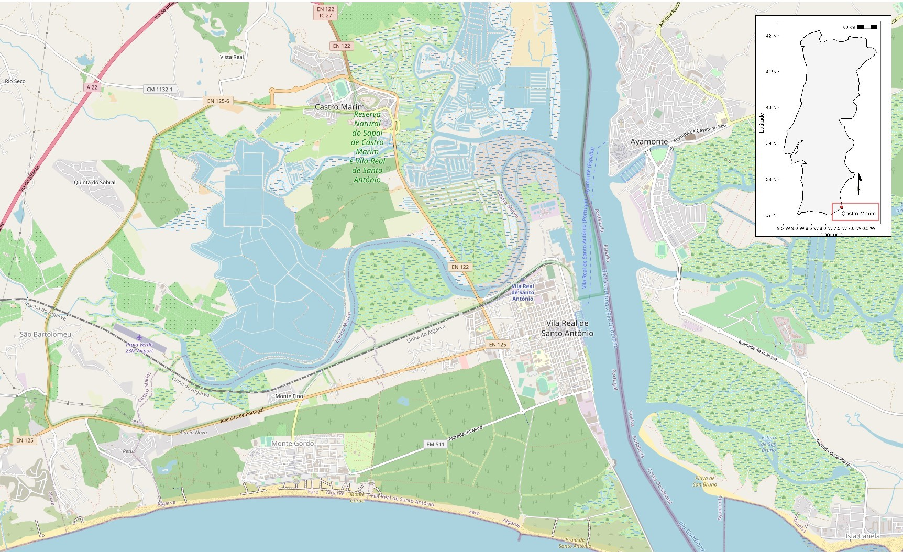

Figure 1: Map indicating the location of Castro Marim on the banks of Guadiana Estuary, Algarve Region of Portugal (www.openstreetmap.org).

## 2.2 Site Background

Castro Marim is located on the Guadiana estuary (Fig. ) as a portal to the metallogenic mineral-rich Baixo – Alentejo region as well as to the fertile cultivable lands in the interior regions. The Iron Age settlement was located on an elevation with adequate natural defensive elements and overlooked vast swatches of land, which allowed domination of estuarine traffic and agricultural activities in its domain of influence. These conditions allowed trade and cultural networks between the indigenous communities with the Mediterranean communities to flourish. The earliest human activities are traced back to the Late Bronze Age with East-West orthogonal settlement architecture around the first half of 7th century B.C.E, in the Orientalising period (Arruda et al., 2013; Arruda, 1996). Phoenician imports and other human presence signs declined from the second half of the 6th century B.C.E till the first half of the 5th century B.C.E (Arruda, 1996). Significant changes in material culture and restructuring of the settlement architecture with a Northeast – Southwest orientation are observed from the second half of the 5th century B.C.E (Arruda et al., 2013, 2006; Arruda and Freitas, 2008). The earlier period’s departure was marked with imports from Greek products – specifically ceramics such as kilikes, skyphoi, and kantharoi (Arruda et al., 2013). This resurgence put Castro Marim back in the Phoenician string of pearls along the Iberian Peninsula’s Atlantic coast till the 3rd century B.C.E (Arruda et al., 2013, 2006; Neville, 1998; Niemeyer, 1984). The Phoenician – Punic period is represented by archaeological phases III, IV, and V.

Being in a littoral zone made it was possible to adopt a wide range of agricultural strategies and husbandry practices at Castro Marim. The presence of cereals (*Hordeum* / *Triticum*), grapes (*Vitis*), pulses (*Vicia* / *Cicer*), and other cultivated species (*Olea* / *Coriandrum*), as well as exploitation of wild woody plants (*Pinus* / *Arbutus* etc.) have been elucidated from the archaeological record (Queiroz et al., 2006). The animals (native to Portugal) include cattle (*Bos taurus*), goat (*Capra hircus*), sheep (*Ovis aries*), pig (*Sus scrofa/domesticus*), red deer (*Cervus elaphus*), and rabbit (*Oryctolagus cuniculus*) (Davis, 2007). The sudden arrival of chicken (*Gallus domesticus*) has been documented, which the Phoenicians introduced in the second half of 5th-century B.C.E (Davis, 2007).

## 2.3 Zooarchaeological assessment

Davis, 2007 carried out the zooarchaeological assessment. Ovicaprids (sheep and goats) followed by pigs and cattle dominate the Castro Marim mammal taxa. Both sheep and goats were equally represented with negligible fluctuations throughout the Iron Age at Castro Marim. The wild species in the assemblage consisted mainly of red deer and rabbits. It is worth mentioning here that no morphometric distinction could be made between wild and domesticated pigs. Both the species are present consistently in all the phases of the settlement. It is worth mentioning that the wild relative of the domesticated pig was not distinguishable from the latter. There is a spike in the presence of bird remains in the later phases of the Iron Age (Phase IV - V), primarily due to the introduction of domesticated chicken. The presence of partridge, a common wild species of Iberia, is also noted. Unlike the chicken, partridge has never been domesticated. Ovicaprids and cattle were kept well into maturity as they were prized more for their secondary purposes than their meat. Sheep and goats were kept for their milk and wool, usually slaughtered after they reach at least two years of age. Cattle were valued for their power to plow in the fields as well as to pull heavy loads. Also, they too, were a source of milk. Pigs, on the other hand, were slaughtered as juveniles as they were primarily reared for slaughter. Most of the red deer found were adults, suggesting a hunting preference of that period as a vital subsidiary source of meat. Chicken seems to be slaughtered at a young age, whereas the partridges at an adult age. The slaughter age indicates the domesticated status of chicken and wild status of partridge, respectively.

## 2.4 Archaeobotanical assessment

The original archaeobotanical assessment was carried out by Queiroz et al. (2006). Cereals make up the most significant fraction of the carpological remains. The bulk of cereals is barley (*Hordeum vulgare*) with a tiny fraction of wheat (*Triticum durum/aestivum*). Pulses are mainly broad beans (*Vicia faba*) and chickpeas (*Cicer arietinum*), of which the former has been present in Portugal since prehistoric times, whereas the latter is introduced as a luxury food in the Roman period from Asia. The presence of grape (*Vitis vinifera/sylvestris*) seeds and carbonized wood is typical, starting from the Roman period in Portugal. The presence of grape seeds in Iron Age Castro Marim indicates cultivation by the local population. The most exciting carpological remains are of coriander (*Coriandrum sativum*) which is not native to Portugal and was supposed to be introduced during medieval times, making this the earliest coriander occurrence in Portugal. Charred pine, oak, ash, and poplar wood were recovered abundantly. The exploitation of wild woody plants for timber and fruits marks the Iberian peninsula’s Phoenician colonization. Due to unforeseen circumstances, these identified remains could not be accessed for isotope analyses. Previously unprocessed sediments were studied again to gain botanical remains.

# 3 Methodological approach

## 3.1 ZooMS Analysis of Ovicaprids

Skeletal elements of goats and sheep are a common occurrence in archaeological contexts. A significant issue plaguing comparative husbandry studies between sheep and goats is the overlap of skeletal elements (Boessneck et al., 1964; Payne, 1969; Schramm, 1967). This is further complicated by the environmental modifications, which erode diagnostic markers and produce undistinguishable fragments (Buckley et al., 2010). Zooarchaeology by Mass Spectrometry (ZooMS) is a high-throughput analytical technique that can discriminate unidentifiable bone fragments. ZooMS exploits the genetically distinct alpha 2 ($α2$) chain of the collagen (I) protein to distinguish between different species. Collagen is the most abundant protein in mammalian tissues, and this allows for its extraction in most scenarios where DNA cannot be retrieved (Lyman, 1994). The genus *Capra* is identified by an m/z at 3093 whereas that of *Ovis* has a peptide marker with an observed m/z at 3033 (Buckley et al., 2010).

## 3.2 Stable isotope analysis of plants and animals

Stable isotope ($δ^{13}C$, and $δ^{15}N$) analyses of faunal bones are valuable means of reconstructing foddering practices and other animal husbandry aspects (Price et al., 2017). The variation in $δ^{13}C$ of terrestrial organisms is determined by the primary producers’ photosynthetic pathway, distinguished as C3, C4, and CAM plants (DeNiro and Epstein, 1978; Farquhar et al., 1989; Kohn, 2010; Tieszen, 1991). Plant species are overwhelmingly C3 in nature, including most cultivated plants such as barley, wheat, oats, potato, and other wild edible plants (Fernández-Crespo et al., 2019). C4 plants consist primarily of tropical grasses, millets, sugarcane, corn, and sorghum. C4 plants thrive in warm and high-temperature environments and thus are restricted to coastal zones in regions with temperate climates (Leegood, 2013; Price et al., 2017). $δ^{13}C$ measurements are also helpful to differentiate between terrestrial and aquatic food sources (Froehle et al., 2010; Kellner and Schoeninger, 2007). $δ^{15}N$ values indicate the isotopic composition of the consumers and their dietary intake to consumers in a food chain (Price et al., 2017). $δ^{15}N$ values can also be used to distinguish between terrestrial and marine diets (Deniro and Epstein, 1981; Webb et al., 2017), consumption of manured, and unmanured crops (Bogaard et al., 2013; Deniro and Epstein, 1981; Fernández-Crespo et al., 2019; Fraser et al., 2013), and trophic level within an established ecosystem (Hedges and Reynard, 2007; Schoeninger, 1985).

There are only two significant inputs, which humans can manipulate to cultivate plants: water and nitrogen input. Variation in $δ^{13}C$ values of plants is primarily due to water availability as any dry spells affect the movement of carbon dioxide through the stomata (Ferrio et al., 2007; Ferrio et al., 2005). The water status of crops can be artificially controlled by irrigation regimes, reflected in $δ^{13}C$ values (Ferrio et al., 2005; Wallace et al., 2013). Therefore, it is essential to convert the absolute $δ^{13}C$ values to carbon discrimination values to facilitate the comparison with the values of the modern crops grown under controlled watering regimes (Farquhar et al., 1989; Wallace et al., 2013):

$$Δ^{13}C=\frac{δ^{13}C_{air}-δ^{13}C_{plant}}{1+δ^{13}C_{plant}/1000}$$

Another major factor, which affects the $δ^{13}C$ measurements, is the canopy effect, where forested areas are more depleted in the heavier 13C isotope compared to open areas (Bonafini et al., 2013). One of the most ancient practices to increase soil fertility is by manuring with animal waste, as animal manure is much higher than endogenous soil in terms of nitrogen isotopic composition (Bogaard et al., 2013). Usually, the plants treated with manure exhibit higher $δ^{15}N$ values (as much as 10) when compared to unfertilized plants (Bogaard et al., 2007; Fraser et al., 2011). The $δ^{13}C$ and $δ^{15}N$ values themselves do not reveal the agricultural practices but reveal patterns when interpreted within a specific site.

The mean $δ^{34}S$ value of terrestrial sources is assumed to be 0. Inorganic sulphur enters the food web through plants from the weathered bedrock (in a complete terrestrial setting), precipitation (sea spray), and microbial activity due to flooding events (Nitsch et al., 2019). As the inorganic sulphur passes through the food web in the form of proteins, only a negligible fractionation occurs between diet and consumer (Hobson, 1999; Nehlich, 2015). Thus, the $δ^{34}S$ ratio of collagen closely reflects that of the native water source, bedrock, and soluble sulphur-bearing minerals.

# 4 Materials and Methods

## 4.1 Sample Selection

Fifty faunal bone samples (Table ) from conclusively adult individuals as well as 9 charred plant macro-remains of *Hordeum vulgare* subsp. *vulgare*, *Hordeum vulgare* subsp. *nudum*, and *Pinus* sp. each have been selected for this study. The sampled faunal bones represent the Phoenician – Punic period of the settlement (phases III, IV, and V), whereas the charred plant macro – remains are from only from phase V due to the absence of plant remains from the older phases.

## 4.2 Archaeobotanical Analysis

200 grams of sediment from each stratigraphic layer of the excavation site was weighed and handpicked for plant macro remains (fruits and charcoal). The recovered remains were examined under a stereomicroscope and taxonomically identified (Table ).

## 4.3 Bone Preservation: Fourier Transform Infrared Spectroscopy

500 – 700 mg of bone was cut using a DREMEL$\text{\textregistered}$ rotary drill with a diamond disc and cleaned of dirt, discoloration, and other foreign content with a dental burr. In addition, compact bone was sampled over spongy bone. Bone fragments were slightly polished with fine sandpaper to obtain a flat surface (Hollund et al., 2013). Infrared spectra were collected using a Bruker$^\text{\textregistered}$ Alpha$^\text{\texttrademark}$ Spectrometer with a single-reflection diamond crystal ATR module. Each spectrum was obtained by an accumulation of 128 scans with a spectral resolution of 4 cm-1, from 2000 cm-1 to 375 cm-1. Infrared Splitting Factor (IRSF) and relative carbonate content (C/P) were calculated using absorbance heights at 565 cm-1, 590 cm-1, 605 cm-1, 1035 cm-1, and 1415 cm-1 wavenumbers (Trueman et al., 2008; Weiner and Bar-Yosef, 1990; Wright and Schwarcz, 1996).

## 4.4 Pretreatment of macrobotanical remains

In carbonized plant macro remains, barley grain samples consist of at least ten whole grains, and pine samples consist of one fruit. Morphologically intact samples were chosen after examination under a stereomicroscope (7-45x magnification) and removing any visibly adhering foreign contaminant. An acid-base-acid (ABA) treatment was applied as a pre-treatment (Bogaard et al., 2013; Fraser et al., 2013). First, the samples are treated with 10 mL of 0.5 M HCl at 70 $\text{\textdegree}$C for 60 minutes (or until effervescing stops) and then rinsed with ultrapure water until a neutral pH was achieved. 10 mL of 0.1 NaOH solution was added to the samples at 70 $\text{\textdegree}$C for 60 minutes and then rinsed with ultrapure water to achieve a neutral pH. Finally, the samples were treated with 0.5 M HCl at 70 $\text{\textdegree}$C for 30-60 minutes, followed by three rinses with ultrapure water and subsequent freeze-drying.

## 4.5 Collagen Extraction

The modified Longin (1971) method was used to extract collagen from faunal bones (Richards and Hedges, 1999). Approximately 600 mg of bone sample was demineralized using 0.5 M HCl at 4 $\text{\textdegree}$C for a fortnight with daily vortex and an acid change after 7 days. Repeated rinses with ultrapure water to reach neutral pH were performed, and the demineralized bones were subjected to an overnight treatment in 0.125 M NaOH at room temperature to remove fulvic and humic acid contamination. The samples were then rinsed repeatedly with ultrapure water to achieve neutrality and gelatinized in 0.01 M HCl at 70 $\text{\textdegree}$C for 48 hours. The impurities were separated by filtering the collagen-containing liquid fraction using Ezee – Filter$^\text{\texttrademark}$ filters (Elkay$^\text{\textregistered}$ Laboratory Products). The solubilized collagen was frozen and subsequently lyophilized for 48 hours.

## 4.6 Stable carbon and nitrogen isotope analysis

0.5 - 0.7 mg of freeze-dried collagen powder/barley grain samples were weighed in tin capsules and combusted in an elemental analyzer (EA) with oxygen (Flash 2000 HT$^\text{\texttrademark}$, Thermo Fisher Scientific$^\text{\textregistered}$, Bremen, Germany) using pure helium as carrier gas. Isotopic ratios were obtained on a Delta V Advantage Continuous Flow$^\text{\texttrademark}$ – Isotope Ratio Mass Spectrometer (Thermo Fisher Scientific$^\text{\textregistered}$, Bremen, Germany). The raw machine output was normalised by a three-point calibration using international standard reference materials (SRM), namely IAEA-CH-6 (sucrose, $δ^{13}C$ = – 10.499), IAEA-600 (caffeine, $δ^{13}C$ = – 27.771; $δ^{15}N$ = + 1), and IAEA-N-2 (ammonium sulphate, $δ^{15}N$ = + 20.3) and in-house standard L-Alanine ( $δ^{13}C$ = – 18.5; $δ^{15}N$ = + 1.1). The standards are regularly (after eleven analyses) included in the analytical routine to correct for instrumental drifts. The isotope values are expressed in per mille () relative to VPDB (Vienna Pee-Dee Belemnite) for carbon and AIR (Ambient Inhalable Reservoir) for nitrogen. In order to correct for charring effect in plant remains, 0.11 and 0.31 were subtracted from their $δ^{13}C$ and $δ^{15}N$ values, respectively (Nitsch et al., 2015). The fluctuations in $δ^{13}C$ of the atmospheric CO2 throughout the Holocene were considered while interpreting the stable carbon isotope ratios. The $δ^{13}C$ of atmospheric CO2 during the period in the study was approximated using the AIRCO2_LOESS system, and then this value was used to compute the $δ^{13}C$ discrimination of plants independent of the source CO2 (Farquhar et al., 1982; Ferrio et al., 2005).

## 4.7 Stable sulphur isotope analysis

The collagen samples were combusted with additional V2O5 and an oxygen pulse (IsoPrime$^\text{\texttrademark}$ Mass spectrometer, Elementar Analysensysteme GmbH$^\text{\textregistered}$, Langenselbold, Germany). Calibration of $δ^{34}S$ values was performed using international inorganic standards for stable sulphur isotope analysis: NBS127 (+20.3) and IAEA S1 (-0.3). B2155 protein (+6.96 ± 0.04) was used as an internal quality control standard. Stable sulphur isotope values are reported in parts per thousand relative to Vienna-Canyon Diablo Troilite (VCDT).

## 4.8 Statistical Analysis

The obtained data were subjected to statistical analysis using R programming language (R Core Team, 2020; Wickham, 2016). Initially, means and standard deviations were calculated per species. Z-scores were calculated to detect the presence of outliers. Deviance from normal distribution was assessed using the Shapiro-Wilks test. F-tests were first used to check for significant equal variance, and subsequently, unpaired Student’s t-tests were used for two-sample comparison since all the datasets were normally distributed.

Charred botanical remains of settlement phase V from Castro Marim; (a) Brassica nigra; (b) Apium sp.; (c) Galeopsis tetrahit; (d) Pisum sativum; (e) Triticum aestivum/durum; (f) Hordeum vulgare nudum; (g) Hordeum vulgare vulgare; (h) Pinus sp.; (i) Vicia faba

Figure 2: Charred botanical remains of settlement phase V from Castro Marim; **(a)** Brassica nigra; **(b)** Apium sp.; **(c)** Galeopsis tetrahit; **(d)** Pisum sativum; **(e)** Triticum aestivum/durum; **(f)** Hordeum vulgare nudum; **(g)** Hordeum vulgare vulgare; **(h)** Pinus sp.; **(i)** Vicia faba

# 5 Results and Discussion

## 5.1 Bone Preservation

### 5.1.1 Fourier Transform - Infrared Spectroscopy

The IRSF index values are in a range of 2.37 - 3.37 (accepted range is 2.96 - 4.04), and the C/P index values are in the range of 0.2-0.428 (accepted range is 0.054 - 0.47), which fall well within the accepted range for well-preserved archaeological bones (Hollund et al., 2013; Lebon et al., 2016).

### 5.1.2 Collagen Quality

Collagen extraction was successful for all the bone samples, based on published criteria, with carbon content between 15.3% and 47.0% (Ambrose, 1990), nitrogen content between 5.5% and 17.3% (Ambrose, 1990), C/N values between 2.9 and 3.6 (DeNiro, 1985), C/S values between 300% and 900% (Nehlich and Richards, 2009), and collagen yields greater than 1% (Klinken, 1999). The extracted bone collagen samples exhibit C/N values ranged between 3.1 and 3.5 and C/S values between 225.9 and 688.4. Carbon and nitrogen amounts range from 20.3% to 50.0% and 7.3% and 18.1% respectively. Collagen yields range between 2.5% to 49.1%. All the faunal samples exhibited collagen quality parameters indicative of good preservation.

(ref:isobot-footnote) $δ^{13}C$ and $δ^{15}N$ values corrected for charring effect.

## 5.2 Botanical Remains

No botanical remains could be recovered from the soil samples of phases I – IV due to the smaller scale of settlements and poor preservation conditions. The bulk of the recovered remains are from phase V representing the most mature chronological period of the occupation. Barley (*Hordeum vulgare*) is the most dominant taxon in the botanical record (Table ). *Hordeum vulgare nudum* and *Hordeum vulgare vulgare* (Fig. **(f)** and **(g)** respectively) are the two cultivars that constitute the barley fraction with equal abundance. Wheat (*Triticum aestivum*) is the second most abundant taxon after barley. Large-scale cereal cultivation has been observed in sites located in river valleys near the South Iberian sea coast (Eg: Castillo de Doña Blanca (Guadalquivir Valley, Spain) and El Villar (Guadalhorce valley, Spain), two sites which are located in similar geographical settings to Castro Marim). Cereal cultivation seems to be a significant activity, implying that cereals were the principal source of carbohydrates for both humans and animals. The greater presence of barley compared to wheat can be a strategy of ‘minimum returns on investment’ against dry climatic conditions exploiting the fact that barley has a higher tolerance to drier conditions than wheat (Riehl, 2009). Two taxa of leguminous plants have been noted, namely, peas (*Pisum sativum*) and broad bean (*Vicia faba*) (Fig. **(d)** and **(i)** respectively). The leguminous plants serve as a rich source of proteins and act as an alternative to animal-sourced protein for humans. The combined cultivation of leguminous plants with cereals helps maintain adequate soil nitrogen levels, leading to sustainable and diverse production. The presence of black mustard (*Brassica nigra*) (Fig. **(a)**) has been recorded. Black mustard is a common species along the rocky Mediterranean coasts and has long found its place as a culinary taste enhancer (Dixon, 2006). Like many members of *Brassica*, black mustard was also used as a source of oil. A fragment of a charred seed has been attributed to *Apium* taxon, suspected to be a seed of celery (*Apium graveolens*) (Fig. **(b)**). This attribution is done due to the presence of five slender longitudinal ridges on the surface of the seed (Wilson, 2016). The species is native to the coastal Mediterranean region, considered to be its center of origin. The recorded use of celery as a vegetable in Europe is only from the 1600s, originating in Italy, gradually spreading westwards in the subsequent centuries (Tobyn et al., 2011). Hortulus, a Strabo poem from 9th century B.C.E., describes the use of celery as a medicinal plant, implying that even if the plant was cultivated as a medicinal herb rather than a food plant (Sturtevant, 1886) in the Phoenician - Punic period. Shells of pine nuts (*Pinus* sp.) (Fig. **(h)**) are suspected to be from the *Pinus pinea* species, commonly known as Mediterranean stone pine. Pine nut consumption has been documented in Portugal since the Palaeolithic period (Gale and Carruthers, 2000). The stone pine nuts are high in protein and fat with low carbohydrates (Haws, 2004). The nuts are a valuable source of nutrition and could have been stored to deal with low cultivated food production periods.

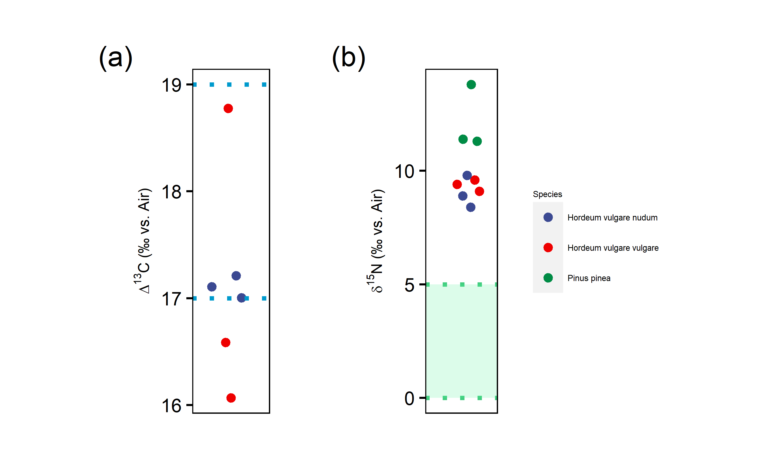

Figure 3: **(a).** Beeswarm plot showing $Δ^{13}C$ values of barley cultivars where the blue dashed lines represent ‘well-watered’, ‘moderately-watered’, and ‘poorly watered’ reference lines based on the study of modern crops in varying watering conditions (Wallace et al., 2013). **(b).** Beeswarm plot showing the manuring status of barley cultivars with green shaded region representing 1 SD range of estimated wild herbivore forage value (calculated from subtraction 4 from red deer $δ^{15}N$ mean ± 1 SD range).

## 5.3 Water and nutrient nitrogen availability for vegetation

Table shows the results of stable isotope ratios of the two barley cultivars and stone pine. In the case of barley, the isotope ratios fall within the established predicted ranges obtained from experimentally charred modern cereals (Fraser et al., 2013). Since the isotope ratios of the stone pine are similar to that of barley, they are considered acceptable. The $δ^{13}C$ values of all the plants are within the range expected for C3 plants with *Hordeum vulgare nudum* having mean values of -23.2 ± 0.1, *Hordeum vulgare vulgare* have -23.2 ± 1.4, and -25.3 ± 0.4 being mean values of *Pinus pinea*. Though the plants are located in salt marshes (Fig. ), the source of carbon is from the atmosphere (Cloern et al., 2002), and thus the values are similar to terrestrial plants. The $δ^{13}C$ means of both cultivars show no statistically significant difference (t-statistic: -0.04, degrees of freedom: 4, *p*-value: 0.97). The $Δ^{13}C$ values (Figure **(a)**) show barley cultivated in poor to moderate watering conditions, which would indicate that the plants have been dependant on natural precipitation with little or no artificial irrigation. It must be emphasized that barley was not growing in water deficit conditions since Castro Marim is surrounded by marshlands, being on the Guadiana estuary.

The plants exhibit high $δ^{15}N$ mean values with *Hordeum vulgare nudum* having 8.7 ± 0.7, *Hordeum vulgare vulgare* mean values of 9.1 ± 0.3); whereas *Pinus pinea* has mean values of 11.9 ± 1.4. There is no significant difference (t-statistic: 0.77, degrees of freedom: 4, *p*-value: 0.49) between the two barley cultivars. The $δ^{15}N$ mean values of the plants in salt marshes are higher when compared to completely inland sites (Cloern et al., 2002). The $δ^{15}N$ isotope ratios are elevated because the coastal/saline soils are enriched in nutrient nitrogen because of nitrate sea-spray, nitrification, denitrification, and ammonium absorption (Ambrose, 1991; Heaton, 1987; Virginia and Delwiche, 1982). The stone pine samples exhibit higher mean values than the barley cultivars despite the possibility that the latter could be subjected to manuring regimes (Figure **(b)**). This indicates that the barley was cultivated in locations farther away from the coastline than the stone pine. Thus, any effects of manure on $δ^{15}N$ isotope ratios of barley are masked by the increase caused by the proximity to the coast/salt marsh.

## 5.4 Faunal bone collagen $δ^{13}C$ and $δ^{15}N$ values

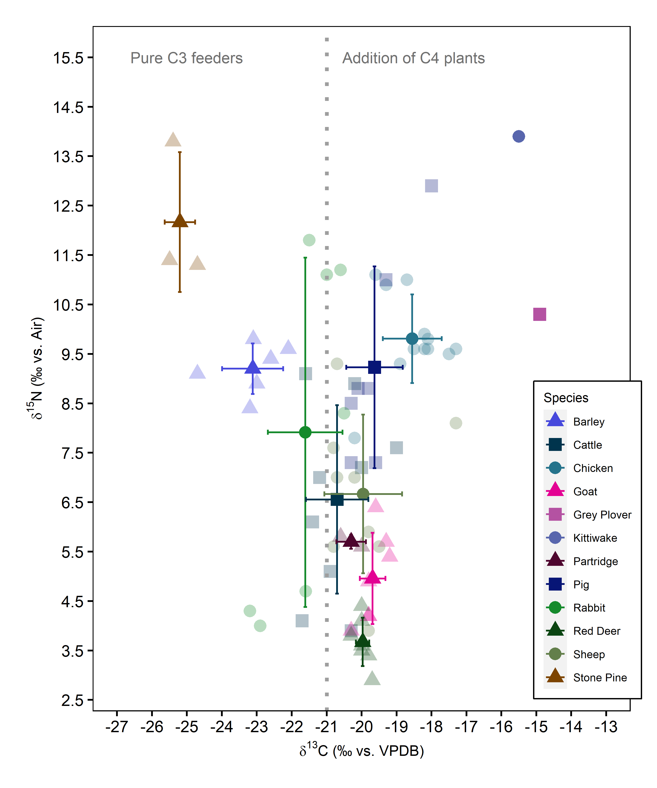

Figure 4: Plot showing mean $δ^{13}C$ and $δ^{15}N$ values of faunal bone collagen. The colour palette is produced with the Colorgorical web app (Gramazio et al., 2017).

### 5.4.1 Wild fauna (mammals)

All fifty faunal samples, with the exception of rabbits (in case of $δ^{15}N$), demonstrate (Table ) stable isotope values within the range expected for a C3 temperate ecosystem. The mean $δ^{13}C$ and $δ^{15}N$ values of red deer are -20 ± 0.2 and 3.7 ± 0.5 respectively. The other undomesticated mammal is the rabbit which has mean $δ^{13}C$ values of -21.6 ± 1.1 and mean $δ^{15}N$ values of 7.9 ± 3.5. The mean $δ^{13}C$ values of red deer are significantly higher than those of rabbits (t-statistic: -4.01, degrees of freedom: 12, *p*-value: 0). This can be attributed to the rabbits’ foraging area, which probably was open forests in contrast with the red deer, which most probably foraged in forested areas with high recycling of CO2 and shade from the higher levels of the canopy. Feeding in forested areas causes the $δ^{13}C$ values to increase due to the canopy effect (Bonafini et al., 2013). The $δ^{15}N$ values of rabbits are anomalous with a standard deviation spanning almost a trophic level (standard deviation of $δ^{15}N$: 3.5). It can be observed from Fig. that the rabbits consist of two distinct groups, indicative that the group with higher $δ^{15}N$ values was foraging in coastal/salt-marsh zones, whereas the other group had more terrestrially located food sources (Figure ).

### 5.4.2 Domesticated fauna (mammals)

Sheep show mean $δ^{13}C$ values of -20 ± 1.1 and mean $δ^{15}N$ values of 6.7 ± 1.6, while goats exhibit mean $δ^{13}C$ values of -19.7 ± 0.4 and mean $δ^{15}N$ values of 5 ± 0.9. Goat mean $δ^{13}C$ values are not significantly different than that of sheep (t-statistic: 0.61, degrees of freedom: 14, *p*-value: 0.55). The ovicaprids’ statistically similar mean $δ^{13}C$ values indicate similar foraging in forested areas (due to slightly positive $δ^{13}C$ values). Sheep exhibit significantly higher $δ^{15}N$ values than goats (t-statistic: 2.5, degrees of freedom: 14, *p*-value: 0.03), demonstrating that sheep were foddered on food sourced from manured vegetation (Figure ). Sheep are superior to goats both in terms of secondary products and ease of management (Davis, 2007; Rutter, 2002). Owing to the more attached economic interests with sheep, it is natural to give food sourced from cultivated crops. Since the coastal/salt marsh effect masks the increase of $δ^{15}N$ values caused by manuring in cultivated crops, this is conclusive proof of manuring practices at Castro Marim. Cattle show mean $δ^{13}C$ values of -20.7 ± 0.9 and mean $δ^{15}N$ values of 6.6 ± 1.9. The cattle have statistically non-significant (t-statistic: -1.57, degrees of freedom: 16, *p*-value: 0.14) $δ^{13}C$ isotope ratios compared to sheep. Cattle also seem to have grazed in forested areas. The $δ^{15}N$ isotope ratios of cattle are also significantly not different from sheep (t-statistic: 0.13, degrees of freedom: 16, *p*-value: 0.9). Though significantly not different than sheep, the mean $δ^{15}N$ values of cattle are higher (Figure ). Most of the cattle bones are from adults, which indicates that they were used as a source of power and only slaughtered for meat towards the end of their lives (Davis, 2007). Since they were used for labour intense tasks, their diet could have a higher ratio of cultivated crop components. Pigs show mean $δ^{13}C$ values of -19.6 ± 0.8 and mean $δ^{15}N$ values of 9.2 ± 2. The high $δ^{15}N$ values of pigs reflect an omnivorous diet consisting of agricultural components and human food scraps.

### 5.4.3 Wild and domesticated birds

Partridges show mean $δ^{13}C$ values of -20.3 ± 0.4 and mean $δ^{15}N$ values of 5.7 ± 0.1 while chicken exhibit mean $δ^{13}C$ values of -18.6 ± 0.8 and mean $δ^{15}N$ values of 9.8 ± 0.9. The $δ^{13}C$ values (t-statistic: 2.8, degrees of freedom: 12, *p*-value: 0.02) and $δ^{15}N$ values (t-statistic: 6.26, degrees of freedom: 12, *p*-value: 4^{-5}) are significantly different. The chicken owing to its domesticated status, has higher $δ^{13}C$ and $δ^{15}N$ values. Chickens are usually reared in domestic spaces while being fed food scraps and possibly fed millet (a C4 plant) (Fernández-Crespo et al., 2019). Chicken also eat insects alongside the human-provided food which can lead to an increase of $δ^{15}N$ values. All the partridges recovered are adults, whereas the chickens constitute juvenile-adult mix, further indicative that the former were hunted for consumption. Grey plover has a mean $δ^{13}C$ value of -14.9 and a mean $δ^{15}N$ value of 10.3. Grey plovers are known to feed in muddy intertidal zones on insects (such as Coleoptera, polychaetes), molluscs, and crustaceans (Perez-Hurtado et al., 1997). The isotope values are consistent with a diet consisting of both terrestrial and marine prey. Kittiwake has a mean $δ^{13}C$ value of -15.5 and a mean $δ^{15}N$ value of 13.9. Kittiwake’s diet consists of fish, marine invertebrates, and plankton (Bull et al., 2004). The $δ^{13}C$ and $δ^{15}N$ values are as expected of a species with a marine diet.

The fauna is not above one trophic level (< 4 $δ^{15}N$) over the plants (both cultivated and wild) (Figure ). Thus, the fauna seems to be foraging in areas away from the coastal/salt-marsh zones. However, the fauna at Castro Marim has relatively higher $δ^{13}C$ and $δ^{15}N$ mean values than entirely terrestrial sites. Two reasons can explain these slightly higher $δ^{15}N$ values. The first reason could be the seasonal exploitation of salt marshes. The seasonal movement of domesticates, also known as transhumance, could cause an increase in $δ^{15}N$ to be evened by the subsequent migration. The seasonal exploitation can be resolved in the future using sequential sampling of faunal dentine. The second reason is due to physiological response due to environmental aridity. The continuous consumption of plants covered with seawater due to sea spray or immersion induces water stress which is countered by excreting $δ^{15}N$ depleted urea from the body (Ambrose, 1991).

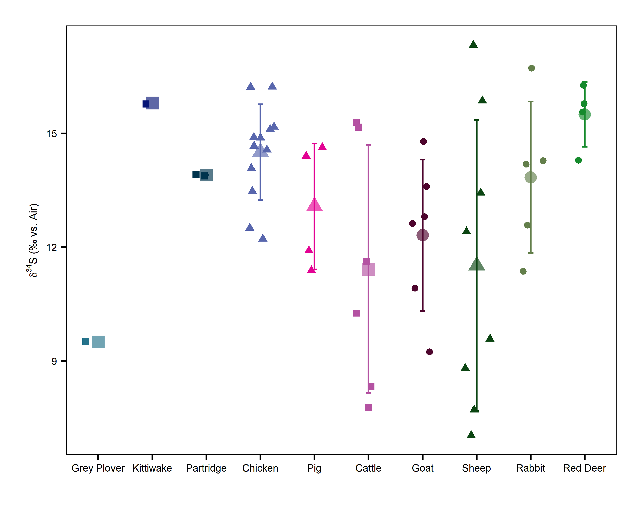

Figure 5: Plot showing mean $δ^{34}S$ values of faunal bone collagen. The values are horizontally jittered to increase the visibility of the data points.

## 5.5 Faunal bone collagen $δ^{34}S$ values

$δ^{34}S$ values of fauna range from 9.5 to 15.8 . The offset of $δ^{34}S$ between diet to collagen is considered to be negligible (Nehlich, 2015). Since the diet-collagen offset is negligible; collagen $δ^{34}S$ values often reflect the local geological settings and sea-spray proximity to the coast (<30 km). The geological substrate of areas surrounding Castro Marim consist primarily of Triassic with small portions of Quaternary bedrock zones (Terrinha, 1998). A compilation of $δ^{34}S$ of Triassic sediments from Western Europe (Claypool et al., 1980) presents a range of 9.5 to 15. Thus, any values between this range can be considered as a signal for local. Both grey plover and kittiwake are known to migrate seasonally, which makes the interpretation of their $δ^{34}S$ values complicated (Coulson, 2011; Thompson and Byrkjedal, 2010). The $δ^{34}S$ values of all other fauna fall within the range of Western European Triassic sediments, thus indicating that they were all of local origin (Figure ). $δ^{34}S$ mean values of rabbits are 13.8 ± 2, and the $δ^{34}S$ mean values of red deer are 15.5 ± 0.9. Both the wild mammals have low standard deviations indicating that individuals are of close spatial origins (Figure ). From the domesticated species, goats have mean $δ^{34}S$ values of 12.3 ± 2, pigs have mean $δ^{34}S$ values of 13.1 ± 1.7, and chickens have mean $δ^{34}S$ values of 14.5 ± 1.3. These three species have relatively low standard deviations similar to wild mammals (Figure ). These three species could have been penned in spaces attached to human residences, giving rise to the low standard deviations. In the case of sheep, the mean $δ^{34}S$ values are 11.5 ± 3.8 while the mean $δ^{34}S$ values of cattle are 11.4 ± 3.3. Sheep and cattle have the highest standard deviation amongst the fauna, which could be caused due to periodic migration (Figure ). Since the $δ^{34}S$ values of sheep and cattle are still within the range of what is considered local, the movement could be somewhere inland within the territory of the settlement.

# 6 Conclusions

The $δ^{13}C$ values of the two barley cultivars indicate complete dependence on natural precipitation with little to no artificial irrigation. In the case of stone pine, $δ^{13}C$ values are non-conclusive concerning watering status due to the lack of established studies for *Pinus* species. The $δ^{15}N$ ratios of the plants are elevated due to the proximity of coast/salt marsh. Though the manuring of barley was masked by the high nitrogen nutrient soils of the salt marshes, it was revealed by the significant differences of mean $δ^{15}N$ values of sheep and goats. The $δ^{15}N$ values of stone pine are greater than those of the barley, indicating that the cultivation took place in locations far away from coast/salt marsh. In the case of wild fauna, the $δ^{13}C$ values of rabbits indicate foraging in open forests, while those of red deer indicate closed forests as the foraging zone. The $δ^{15}N$ values of rabbits indicate two different groups, with one group foraging in salt marshes and the other from a more terrestrial setting. Ovicaprid $δ^{13}C$ values indicate foraging in forested areas. Comparing the $δ^{15}N$ ratios of sheep and goats show that the former was fed agricultural produce/by-products, which the latter lacked. The cattle also foraged in forested areas and had a higher ratio of cultivated components in its diet compared to the sheep. Pigs exhibit $δ^{13}C$ and $δ^{15}N$ values consistent with an omnivorous diet. In the case of the seabirds, both grey plover and kittiwake exhibit $δ^{13}C$ and $δ^{15}N$ values consistent with their diet. Chicken has $δ^{13}C$ and $δ^{15}N$ values reflective of its domesticated status with a mixture of C3 and C4 (millets) plants, insects, and food scraps. The $δ^{15}N$ values of the fauna are not a trophic level above the plants, which can be because of either seasonal movement or aridity. The $δ^{34}S$ values of all fauna indicate a local origin. Goats, pigs, and chickens have a low range of values due to penning in domestic spaces. The $δ^{34}S$ values of cattle and sheep have a more extensive range of values which could be due to seasonal migration. This study is the first of its kind on Phoenician-Punic fauna from the Iberian Peninsula. The study has given a preliminary insight into the cultivation and husbandry practices in Castro Marim during the Iron Age. The stable isotope data has also raised the possibility of transhumance at Castro Marim, which can only be answered in future studies.

# 7 Acknowledgements

This project has received funding from the European Union’s Horizon 2020 research and innovation programme under the Marie Skłodowska-Curie grant agreement No. 766311.

# References

Ambrose, S.H., 1990. Preparation and characterization of bone and tooth collagen for isotopic analysis. Journal of Archaeological Science 17, 431–451. doi:[10.1016/0305-4403(90)90007-R](https://doi.org/10.1016/0305-4403(90)90007-R)

Ambrose, S.H., 1991. Effects of diet, climate and physiology on nitrogen isotope abundances in terrestrial foodwebs. Journal of Archaeological Science 18, 293–317. doi:[10.1016/0305-4403(91)90067-Y](https://doi.org/10.1016/0305-4403(91)90067-Y)

Arrastio, F.J.M., 1999. Conflictos y perspectivas en el periodo precolonial tartésico. Gerión. Revista de Historia Antigua 17, 149.

Arrastio, F.J.M., 2000. Tartessos, estelas, modelos pesimistas, in: Intercambio y Comercio Preclásico En El Mediterráneo: Actas Del I Coloquio Del CEFYP, Madrid, 9-12 de Noviembre, 1998. Centro de Estudios Fenicios y Púnicos, pp. 153–174.

Arruda, A.M., 1996. O Castelo de Castro Marim, in: In De Ulisses a Viriato. O Primeiro Milénio a.C.. Ministério da Cultura, Instituto Português de Museus, Museu Nacional de Arqueologia, Lisboa, pp. 95–100.

Arruda, A.M., 2003. Contributo da colonização fenícia para a domesticação da terra portuguesa. Ecohistoria del paisaje agrario-la agricultura fenicio-púnica en el mediterráneo.

Arruda, A.M., 2009. Phoenician colonization on the Atlantic Coast of the Iberian Peninsula. Chicago: The University of Chicago Press, 2009.

Arruda, A.M., Freitas, V.T. de, 2008. O castelo de castro marim durante os séculos VI e v a.n.e. Sidereum Ana I: El río Guadiana en época Post-Orientalizante. 429–446.

Arruda, A.M., Soares, A.M., Freitas, V.T. de, Oliveira, C.F., Martins, J.M.M., Portela, P.J., 2013. A cronologia relativa e absoluta da ocupação sidérica do Castelo de Castro Marim. Saguntum 45, 101–114.

Arruda, A.M., Viegas, C., Bargão, P., Pereira, R., 2006. A importação de preparados de peixe em Castro Marim: Da Idade do Ferro á Época Romana. Setúbal Arqueológica 13, 153–176.

Aubet, M.E., 2001. The Phoenicians and the West: Politics, colonies and trade. Cambridge Univ. Press.

Boessneck, J., Müller, H.-H., Teichert, M., 1964. Osteologische Unterscheidungsmerkmale zwischen Schaf (Ovis aries Linné) und Ziege (Capra hircus Linné). Verlag nicht ermittelbar.

Bogaard, A., Fraser, R., Heaton, T.H.E., Wallace, M., Vaiglova, P., Charles, M., Jones, G., Evershed, R.P., Styring, A.K., Andersen, N.H., Arbogast, R.-M., Bartosiewicz, L., Gardeisen, A., Kanstrup, M., Maier, U., Marinova, E., Ninov, L., Schäfer, M., Stephan, E., 2013. Crop manuring and intensive land management by Europe’s first farmers. PNAS 110, 12589–12594. doi:[10.1073/pnas.1305918110](https://doi.org/10.1073/pnas.1305918110)

Bogaard, A., Heaton, T.H.E., Poulton, P., Merbach, I., 2007. The impact of manuring on nitrogen isotope ratios in cereals: Archaeological implications for reconstruction of diet and crop management practices. Journal of Archaeological Science 34, 335–343. doi:[10.1016/j.jas.2006.04.009](https://doi.org/10.1016/j.jas.2006.04.009)

Bonafini, M., Pellegrini, M., Ditchfield, P., Pollard, A.M., 2013. Investigation of the ’canopy effect’ in the isotope ecology of temperate woodlands. Journal of Archaeological Science 40, 3926–3935. doi:[10.1016/j.jas.2013.03.028](https://doi.org/10.1016/j.jas.2013.03.028)

Buckley, M., Whitcher Kansa, S., Howard, S., Campbell, S., Thomas-Oates, J., Collins, M., 2010. Distinguishing between archaeological sheep and goat bones using a single collagen peptide. Journal of Archaeological Science 37, 13–20. doi:[10.1016/j.jas.2009.08.020](https://doi.org/10.1016/j.jas.2009.08.020)

Bull, J., Wanless, S., Elston, D.A., Daunt, F., Lewis, S., Harris, M.P., J, B., Wanless, S., Elston, D.A., Daunt, F., Lewis, S., Harris, M.P., 2004. Local-scale variability in the diet of Black-legged Kittiwakes Rissa tridactyla. Ardea 43–52.

Claypool, G.E., Holser, W.T., Kaplan, I.R., Sakai, H., Zak, I., 1980. The age curves of sulfur and oxygen isotopes in marine sulfate and their mutual interpretation. Chemical Geology 28, 199–260. doi:[10.1016/0009-2541(80)90047-9](https://doi.org/10.1016/0009-2541(80)90047-9)

Cloern, J.E., Canuel, E.A., Harris, D., 2002. Stable carbon and nitrogen isotope composition of aquatic and terrestrial plants of the San Francisco Bay estuarine system. Limnology and Oceanography 47, 713–729. doi:[10.4319/lo.2002.47.3.0713](https://doi.org/10.4319/lo.2002.47.3.0713)

Coulson, J., 2011. The kittiwake. A&C Black.

Davis, S., 2007. The mammals and birds from the Iron Age and Roman periods of Castro Marim, Algarve, Portugal. Trabalhos do CIPA 107.

Deniro, M.J., Epstein, S., 1981. Influence of diet on the distribution of nitrogen isotopes in animals. Geochimica et Cosmochimica Acta 45, 341–351. doi:[10.1016/0016-7037(81)90244-1](https://doi.org/10.1016/0016-7037(81)90244-1)

DeNiro, M.J., 1985. Postmortem preservation and alteration of in vivo bone collagen isotope ratios in relation to palaeodietary reconstruction. Nature 317, 806–809. doi:[10.1038/317806a0](https://doi.org/10.1038/317806a0)

DeNiro, M.J., Epstein, S., 1978. Influence of diet on the distribution of carbon isotopes in animals. Geochimica et Cosmochimica Acta 42, 495–506. doi:[10.1016/0016-7037(78)90199-0](https://doi.org/10.1016/0016-7037(78)90199-0)

Dietler, M., 2009. Colonial encounters in Iberia and the Western Mediterranean: An exploratory framework.

Dixon, G.R., 2006. Origins and diversity of Brassica and its relatives., in: Dixon, G.R. (Ed.), Vegetable Brassicas and Related Crucifers. CABI, Wallingford, pp. 1–33. doi:[10.1079/9780851993959.0001](https://doi.org/10.1079/9780851993959.0001)

Eshel, T., Erel, Y., Yahalom-Mack, N., Tirosh, O., Gilboa, A., 2019. Lead isotopes in silver reveal earliest Phoenician quest for metals in the west Mediterranean. Proc Natl Acad Sci USA 116, 6007. doi:[10.1073/pnas.1817951116](https://doi.org/10.1073/pnas.1817951116)

Farquhar, G.D., Ehleringer, J.R., Hubick, K.T., 1989. Carbon Isotope Discrimination and Photosynthesis. Annu. Rev. Plant. Physiol. Plant. Mol. Biol. 40, 503–537. doi:[10.1146/annurev.pp.40.060189.002443](https://doi.org/10.1146/annurev.pp.40.060189.002443)

Farquhar, G., O’Leary, M., Berry, J., 1982. On the Relationship Between Carbon Isotope Discrimination and the Intercellular Carbon Dioxide Concentration in Leaves. Functional Plant Biol. 9, 121. doi:[10.1071/PP9820121](https://doi.org/10.1071/PP9820121)

Fernández-Crespo, T., Ordoño, J., Bogaard, A., Llanos, A., Schulting, R., 2019. A snapshot of subsistence in Iron Age Iberia: The case of La Hoya village. Journal of Archaeological Science: Reports 28, 102037. doi:[10.1016/j.jasrep.2019.102037](https://doi.org/10.1016/j.jasrep.2019.102037)

Ferrio, J.P., Araus, J.L., Buxó, R., Voltas, J., Bort, J., 2005. Water management practices and climate in ancient agriculture: Inferences from the stable isotope composition of archaeobotanical remains. Veget Hist Archaeobot 14, 510–517. doi:[10.1007/s00334-005-0062-2](https://doi.org/10.1007/s00334-005-0062-2)

Ferrio, J.P., Voltas, J., Alonso, N., Araus, J.L., 2007. Reconstruction of Climate and Crop Conditions in the Past Based on the Carbon Isotope Signature of Archaeobotanical Remains, in: Terrestrial Ecology. Elsevier, pp. 319–332. doi:[10.1016/S1936-7961(07)01020-2](https://doi.org/10.1016/S1936-7961(07)01020-2)

Fraser, R.A., Bogaard, A., Charles, M., Styring, A.K., Wallace, M., Jones, G., Ditchfield, P., Heaton, T.H.E., 2013. Assessing natural variation and the effects of charring, burial and pre-treatment on the stable carbon and nitrogen isotope values of archaeobotanical cereals and pulses. Journal of Archaeological Science 40, 4754–4766. doi:[10.1016/j.jas.2013.01.032](https://doi.org/10.1016/j.jas.2013.01.032)

Fraser, R.A., Bogaard, A., Heaton, T., Charles, M., Jones, G., Christensen, B.T., Halstead, P., Merbach, I., Poulton, P.R., Sparkes, D., Styring, A.K., 2011. Manuring and stable nitrogen isotope ratios in cereals and pulses: Towards a new archaeobotanical approach to the inference of land use and dietary practices. Journal of Archaeological Science 38, 2790–2804. doi:[10.1016/j.jas.2011.06.024](https://doi.org/10.1016/j.jas.2011.06.024)

Froehle, A.W., Kellner, C.M., Schoeninger, M.J., 2010. FOCUS: Effect of diet and protein source on carbon stable isotope ratios in collagen: Follow up to Warinner and Tuross (2009). Journal of Archaeological Science 37, 2662–2670. doi:[10.1016/j.jas.2010.06.003](https://doi.org/10.1016/j.jas.2010.06.003)

Gale, R., Carruthers, W., 2000. Charcoal and charred seed remains from Middle Palaeolithic levels at Gorham’s and Vanguard Caves. Neanderthals on the Edge. Oxford: Oxbow Books 207–210.

Gomes, F.B., Arruda, A.M., 2018. On the edge of history? The Early Iron Age of southern Portugal, between texts and archaeology. World Archaeology 50, 764–780. doi:[10.1080/00438243.2019.1604258](https://doi.org/10.1080/00438243.2019.1604258)

Gómez Bellard, C., 2019. Agriculture, in: The Oxford Handbook of The Phoenician and Punic Mediterranean. Oxford University Press, pp. 732–745.

Gramazio, C.C., Laidlaw, D.H., Schloss, K.B., 2017. Colorgorical: Creating discriminable and preferable color palettes for information visualization. IEEE Trans. Visual. Comput. Graphics 23, 521–530. doi:[10.1109/TVCG.2016.2598918](https://doi.org/10.1109/TVCG.2016.2598918)

Haws, J., 2004. An Iberian perspective on Upper Paleolithic plant consumption. Promontoria 2, 49–106.

Heaton, T.H.E., 1987. The $​^{15}N$/ $​^{14}N$ ratios of plants in South Africa and Namibia: Relationship to climate and coastal/saline environments. Oecologia 74, 236–246. doi:[10.1007/BF00379365](https://doi.org/10.1007/BF00379365)

Hedges, R.E.M., Reynard, L.M., 2007. Nitrogen isotopes and the trophic level of humans in archaeology. Journal of Archaeological Science 34, 1240–1251. doi:[10.1016/j.jas.2006.10.015](https://doi.org/10.1016/j.jas.2006.10.015)

Hobson, K.A., 1999. Tracing origins and migration of wildlife using stable isotopes: A review. Oecologia 120, 314–326. doi:[10.1007/s004420050865](https://doi.org/10.1007/s004420050865)

Hollund, H.I., Ariese, F., Fernandes, R., Jans, M.M.E., Kars, H., 2013. Testing an Alternative High-Throughput Tool for Investigating Bone Diagenesis: Ftir in Attenuated Total Reflection (atr) Mode*. Archaeometry 55, 507–532. doi:[10.1111/j.1475-4754.2012.00695.x](https://doi.org/10.1111/j.1475-4754.2012.00695.x)

Kellner, C.M., Schoeninger, M.J., 2007. A simple carbon isotope model for reconstructing prehistoric human diet. American Journal of Physical Anthropology 133, 1112–1127. doi:[10.1002/ajpa.20618](https://doi.org/10.1002/ajpa.20618)

Klinken, G.J. van, 1999. Bone Collagen Quality Indicators for Palaeodietary and Radiocarbon Measurements. Journal of Archaeological Science 26, 687–695. doi:[10.1006/jasc.1998.0385](https://doi.org/10.1006/jasc.1998.0385)

Kohn, M.J., 2010. Carbon isotope compositions of terrestrial C3 plants as indicators of (paleo)ecology and (paleo)climate. Proc Natl Acad Sci U S A 107, 19691–19695. doi:[10.1073/pnas.1004933107](https://doi.org/10.1073/pnas.1004933107)

Lebon, M., Reiche, I., Gallet, X., Bellot-Gurlet, L., Zazzo, A., 2016. Rapid Quantification of Bone Collagen Content by ATR-FTIR Spectroscopy. Radiocarbon 58, 131–145. doi:[10.1017/RDC.2015.11](https://doi.org/10.1017/RDC.2015.11)

Leegood, R.C., 2013. Photosynthesis, in: Lennarz, W.J., Lane, M.D. (Eds.), Encyclopedia of Biological Chemistry (Second Edition). Academic Press, Waltham, pp. 492–496. doi:[10.1016/B978-0-12-378630-2.00049-9](https://doi.org/10.1016/B978-0-12-378630-2.00049-9)

Longin, R., 1971. New Method of Collagen Extraction for Radiocarbon Dating. Nature 230, 241–242. doi:[10.1038/230241a0](https://doi.org/10.1038/230241a0)

Lyman, R.L., 1994. Vertebrate taphonomy. Cambridge University Press.

Manfredi, L.I., 1992. Le saline et il sale nel mundo punico. Rivista di Studi Fenici 20, 3–14.

Markoe, G.E., 2005. Phoenicians. London: The British Museum.

Martin, R., 1971. Recherches sur les agronomes latins et leurs conceptions économiques et sociales.

Nehlich, O., 2015. The application of sulphur isotope analyses in archaeological research: A review. Earth-Science Reviews 142, 1–17. doi:[10.1016/j.earscirev.2014.12.002](https://doi.org/10.1016/j.earscirev.2014.12.002)

Nehlich, O., Richards, M.P., 2009. Establishing collagen quality criteria for sulphur isotope analysis of archaeological bone collagen. Archaeological and Anthropological Sciences 1, 59–75. doi:[10.1007/s12520-009-0003-6](https://doi.org/10.1007/s12520-009-0003-6)

Neville, A., 1998. The Phoenicians in Iberia: Settlements, Cemetries, Trade and Agriculture.

Niemeyer, H.G., 1984. Die Phönizier und die Mittelmeerwelt im Zeitalter Homers. Jahrbuch des Römisch-Germanischen Zentralmuseums.

Nitsch, E.K., Charles, M., Bogaard, A., 2015. Calculating a statistically robust $δ^{13}C$ and $δ^{15}N$ offset for charred cereal and pulse seeds. STAR: Science & Technology of Archaeological Research 1, 1–8. doi:[10.1179/2054892315Y.0000000001](https://doi.org/10.1179/2054892315Y.0000000001)

Nitsch, E.K., Lamb, A.L., Heaton, T.H.E., Vaiglova, P., Fraser, R., Hartman, G., Moreno-Jiménez, E., López-Piñeiro, A., Peña-Abades, D., Fairbairn, A., Eriksen, J., Bogaard, A., 2019. The Preservation and Interpretation of $δ^{34}$ S Values in Charred Archaeobotanical Remains. Archaeometry 61, 161–178. doi:[10.1111/arcm.12388](https://doi.org/10.1111/arcm.12388)

Payne, S., 1969. A metrical distinction between sheep and goat metacarpals. The domestication and exploitation of plants and animals 295–305.

Perez-Hurtado, A., Goss-Custard, J.D., Garcia, F., 1997. The diet of wintering waders in cádiz bay, southwest spain. Bird Study 44, 45–52. doi:[10.1080/00063659709461037](https://doi.org/10.1080/00063659709461037)

Price, G.C., Krigbaum, J., Shelton, K., 2017. Stable isotopes and discriminating tastes: Faunal management practices at the Late Bronze Age settlement of Mycenae, Greece. Journal of Archaeological Science: Reports 14, 116–126. doi:[10.1016/j.jasrep.2017.05.034](https://doi.org/10.1016/j.jasrep.2017.05.034)

Queiroz, P., Mateus, J., Leeuwaarden, W., Pereira, T., Dise, D., 2006. Castro Marim e o seu território imediato durante a Antiguidade. Paleo-etno-Botânica. Relatório Final. doi:[10.13140/RG.2.2.25361.63848](https://doi.org/10.13140/RG.2.2.25361.63848)

Quinn, J., 2019. In search of the Phoenicians. Princeton University Press.

R Core Team, 2020. R: A Language and Environment for Statistical Computing. R Foundation for Statistical Computing, Vienna, Austria.

Renzi, M., Rovira Llorens, S., Montero Ruiz, I., 2012. Riflessioni sulla metallurgia fenicia dell’argento nella Penisola Iberica.

Richards, M.P., Hedges, R.E.M., 1999. Stable Isotope Evidence for Similarities in the Types of Marine Foods Used by Late Mesolithic Humans at Sites Along the Atlantic Coast of Europe. Journal of Archaeological Science 26, 717–722. doi:[10.1006/jasc.1998.0387](https://doi.org/10.1006/jasc.1998.0387)

Riehl, S., 2009. Archaeobotanical evidence for the interrelationship of agricultural decision-making and climate change in the ancient Near East. Quaternary International 197, 93–114. doi:[10.1016/j.quaint.2007.08.005](https://doi.org/10.1016/j.quaint.2007.08.005)

Roller, D.W., 2014. The geography of Strabo: An English translation, with introduction and notes. Cambridge University Press.

Rutter, S.M., 2002. Behaviour of Sheep and Goats, in: The Ethology of Domestic Animals: An Introductory Text. pp. 148–155.

Schoeninger, M.J., 1985. Trophic level effects on 15N/14N and 13C/12C ratios in bone collagen and strontium levels in bone mineral. Journal of Human Evolution 14, 515–525. doi:[10.1016/S0047-2484(85)80030-0](https://doi.org/10.1016/S0047-2484(85)80030-0)

Schramm, Z., 1967. Morphological differences of some goat and sheep bones. Wyższa Szkoła Rolnicza.

Sturtevant, E.L., 1886. History of Celery. The American Naturalist 20, 599–606. doi:[10.1086/274288](https://doi.org/10.1086/274288)

Terrinha, P.A.G., 1998. Structural geology and tectonic evolution of the Algarve Basin, South Portugal. Imperial College London (University of London).

Thompson, D., Byrkjedal, I., 2010. Tundra plovers: The Eurasian, Pacific and American golden plovers and grey plover. A&C Black.

Tieszen, L.L., 1991. Natural variations in the carbon isotope values of plants: Implications for archaeology, ecology, and paleoecology. Journal of Archaeological Science 18, 227–248. doi:[10.1016/0305-4403(91)90063-U](https://doi.org/10.1016/0305-4403(91)90063-U)

Tobyn, G., Denham, A., Whitelegg, M., 2011. CHAPTER 9 - Apium graveolens, wild celery, in: Tobyn, G., Denham, A., Whitelegg, M. (Eds.), Medical Herbs. Churchill Livingstone, Edinburgh, pp. 79–89. doi:[10.1016/B978-0-443-10344-5.00014-8](https://doi.org/10.1016/B978-0-443-10344-5.00014-8)

Treumann, B., 2009. Lumbermen and Shipwrights: Phoenicians on the Mediterranean Coast of Southern Spain.

Treumann, B.W., 1998. The role of wood in the rise and decline of the Phoenician settlements on the Iberian Peninsula.

Trueman, C.N., Privat, K., Field, J., 2008. Why do crystallinity values fail to predict the extent of diagenetic alteration of bone mineral? Palaeogeography, Palaeoclimatology, Palaeoecology 266, 160–167. doi:[10.1016/j.palaeo.2008.03.038](https://doi.org/10.1016/j.palaeo.2008.03.038)

Uriel, P.F., 2000. El comercio de la púrpura, in: Intercambio y Comercio Preclásico En El Mediterráneo: Actas Del I Coloquio Del CEFYP, Madrid, 9-12 de Noviembre, 1998. Centro de Estudios Fenicios y Púnicos, pp. 271–280.

Virginia, R.A., Delwiche, C.C., 1982. Natural $​^{15}N$ abundance of presumed $N_{2}$-fixing and non- $N_{2}$-fixing plants from selected ecosystems. Oecologia 54, 317–325.

Wagner, C.G., Alvar, J., 1989. Fenicios en Occidente: La colonización agrícola. Rivista di Studi Fenici 17, 61–102.

Wagner, C.G., Alvar, J., 2003. La colonización agrícola en la Península Ibérica. Estado de la cuestión y nuevas perspectivas. Ecohistoria del paisaje agrario. La agricultura fenicio-púnica en el Mediterráneo 95, 187–204.

Wallace, M., Jones, G., Charles, M., Fraser, R., Halstead, P., Heaton, T.H.E., Bogaard, A., 2013. Stable carbon isotope analysis as a direct means of inferring crop water status and water management practices. World Archaeology 45, 388–409. doi:[10.1080/00438243.2013.821671](https://doi.org/10.1080/00438243.2013.821671)

Webb, E.C., Lewis, J., Shain, A., Kastrisianaki-Guyton, E., Honch, N.V., Stewart, A., Miller, B., Tarlton, J., Evershed, R.P., 2017. The influence of varying proportions of terrestrial and marine dietary protein on the stable carbon-isotope compositions of pig tissues from a controlled feeding experiment. STAR: Science & Technology of Archaeological Research 3, 28–44. doi:[10.1080/20548923.2016.1275477](https://doi.org/10.1080/20548923.2016.1275477)

Weiner, S., Bar-Yosef, O., 1990. States of preservation of bones from prehistoric sites in the Near East: A survey. Journal of Archaeological Science 17, 187–196. doi:[10.1016/0305-4403(90)90058-D](https://doi.org/10.1016/0305-4403(90)90058-D)

Wickham, H., 2016. Ggplot2: Elegant Graphics for Data Analysis. Springer-Verlag New York.

Wilson, L., 2016. Spices and Flavoring Crops: Fruits and Seeds, in: Caballero, B., Finglas, P.M., Toldrá, F. (Eds.), Encyclopedia of Food and Health. Academic Press, Oxford, pp. 73–83. doi:[10.1016/B978-0-12-384947-2.00647-4](https://doi.org/10.1016/B978-0-12-384947-2.00647-4)

Wood, J.R., Montero-Ruiz, I., Martinón-Torres, M., 2019. From Iberia to the Southern Levant: The Movement of Silver Across the Mediterranean in the Early Iron Age. Journal of World Prehistory 32, 1–31. doi:[10.1007/s10963-018-09128-3](https://doi.org/10.1007/s10963-018-09128-3)

Wright, L.E., Schwarcz, H.P., 1996. Infrared and Isotopic Evidence for Diagenesis of Bone Apatite at Dos Pilas, Guatemala: Palaeodietary Implications. Journal of Archaeological Science 23, 933–944. doi:[10.1006/jasc.1996.0087](https://doi.org/10.1006/jasc.1996.0087)